Ideation Phase
Brainstorm & Idea Prioritization

Date | 26 September 2026
Team ID | SWTID-2026-9376
Project Name | FitTrack AI – Personalized Fitness Recommendations Powered by AI
Maximum Marks | 4 Marks

Brainstorm & Idea Prioritization:
Step-1: Team Gathering, Collaboration and Select the Problem Statement
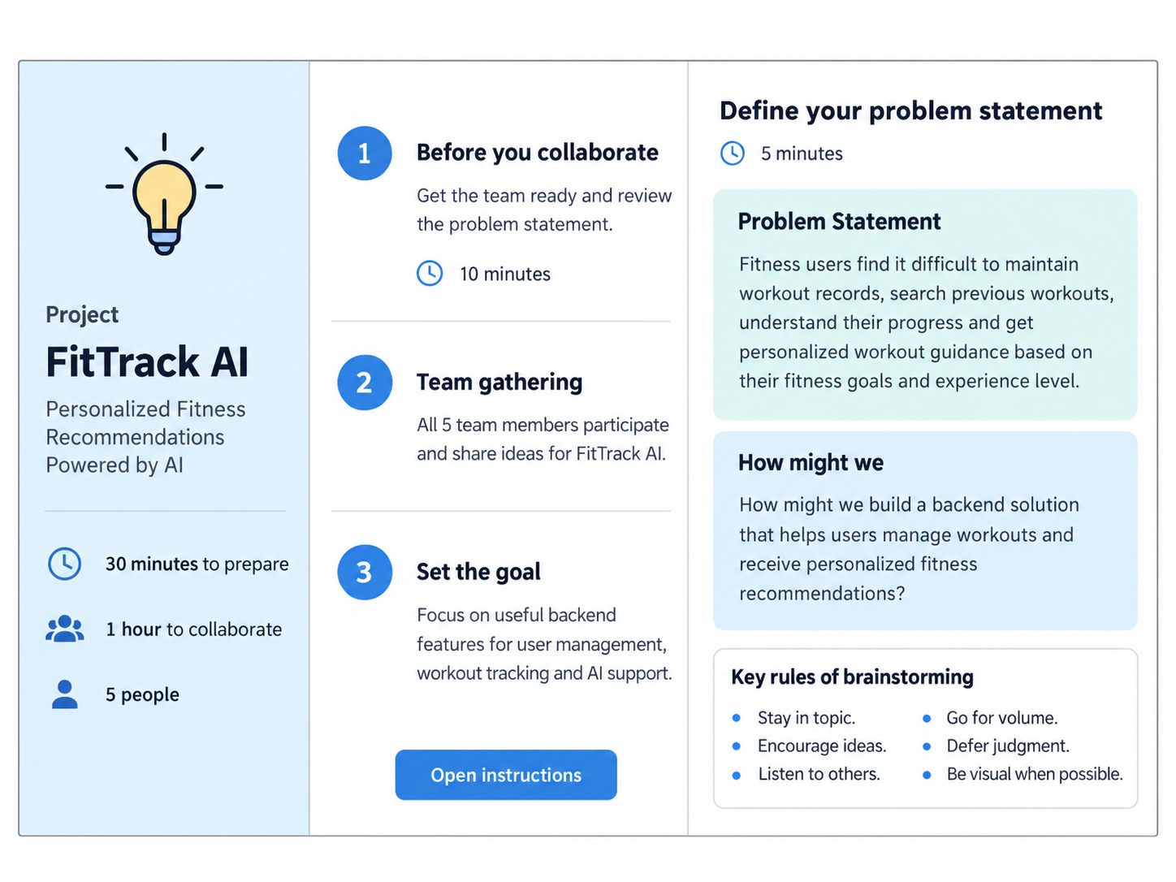

Step-2: Brainstorm, Idea Listing and Grouping
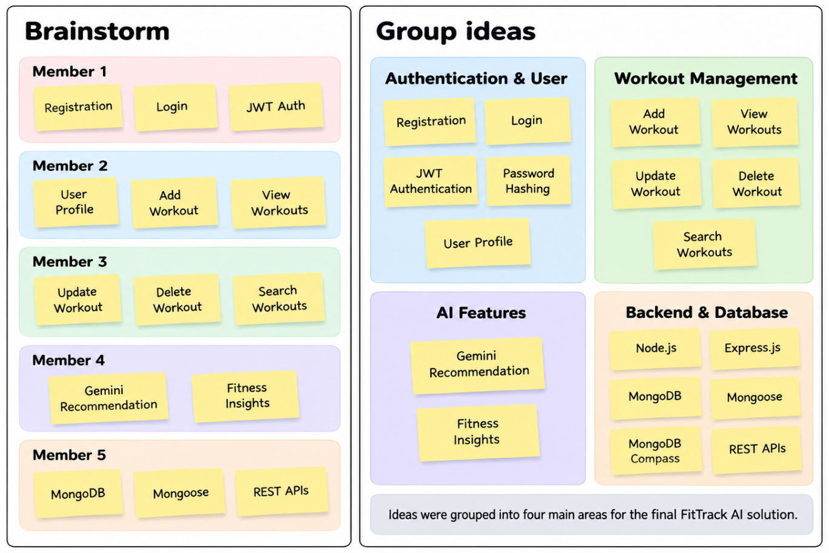

Step-3: Idea Prioritization


